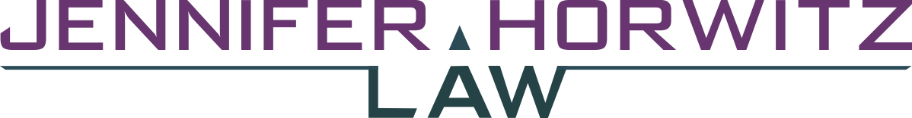

P.O. BOX 70859 | SEATTLE, WA 98127 | PHONE (206) 799-2797

December 20, 2017

Joe Smith (DOC#XXXXXX)
MCC-WSRU, A-213-L
P.O. Box 777
Monroe, WA 98272

Dear Joe:

I am overjoyed at the outcome of your clemency hearing. Congratulations on receiving a unanimous recommendation of clemency from the Clemency and Pardons Board!

I have enclosed a couple of pictures that were taken by Jennifer Smith from the Seattle Clemency Project of me with some of the people who came to Olympia for your hearing.

The next step is waiting for the Governor's office to review your materials and the Board's recommendation and work with DOC to formulate the conditions of release. This process can typically take about 6 months. If there is any change in your health or that of your core family members while we are waiting, please alert me so I can update the Governor's office. I will be checking in with them regularly while we await their decision.

In the meantime, I contacted your counselor and requested that you get access to re-entry programming. Please take advantage of all additional programming that you now have access to while at Monroe while you are waiting for the next phase of the clemency process. Please send me certificates of completion for any programs you participate in so I can forward that information to the Governor's office.

It has been one of the great privileges of my career to work with you and your family to try to secure your release and I am so happy at the decision of the Board on your behalf.

I hope to talk to you soon.

Jennifer Horwitz

