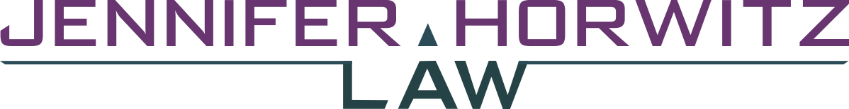

P.O. BOX 70859 | SEATTLE, WA 98127 | PHONE (206) 799-2797

October 26, 2017

Friend or Family Member
Number and Street.
Seattle, WA Zip

Clemency Hearing for Joe Smith December 7, 2017 at 9:00 am

Dear Friend or Family member:

I am writing with some great news about Joe Smith. While not everyone who submits a petition for clemency receives a hearing before the Clemency and Pardons Board, Joe was one of the petitioners who was granted a hearing. Initially, his hearing was set for March 2018, but when a slot opened up for an earlier hearing in December, the Board wanted to move his case to the earlier hearing slot. This suggests to me that Joe has a real shot at getting a vote for clemency from the Board.

If the Board does vote to grant Joe clemency, this will be a recommendation to the Governor of Washington, who very often follows the Board's recommendation. The Governor will then need to sign off on a grant of clemency in order for the remainder of Joe's life sentence to be commuted and for Joe to be released. The Governor's office will typically take about 6 months to review a request for release after a positive recommendation from the Clemency Board.

I have enclosed the official notification letter so you can be aware of all the details such as the exact location of the hearing in Olympia. It is absolutely essential that Joe have a good showing of support from family and friends at the hearing on December 7, 2017.

You are one of Joe's core people to assist him in transitioning if he is released, so I hope, not only that you will come to the hearing, but that you will work with me to prepare a statement to make to the Board. You can call me at (206) 799-2797 or email me at: jennifer@jenniferhorwitzlaw.com to connect to work on what you will say.

Thank you for your important support!

Sincerely,

Jennifer Horwitz

